[Grab your reader’s attention with a great quote from the document or use this space to emphasize a key point. To place this text box anywhere on the page, just drag it.]
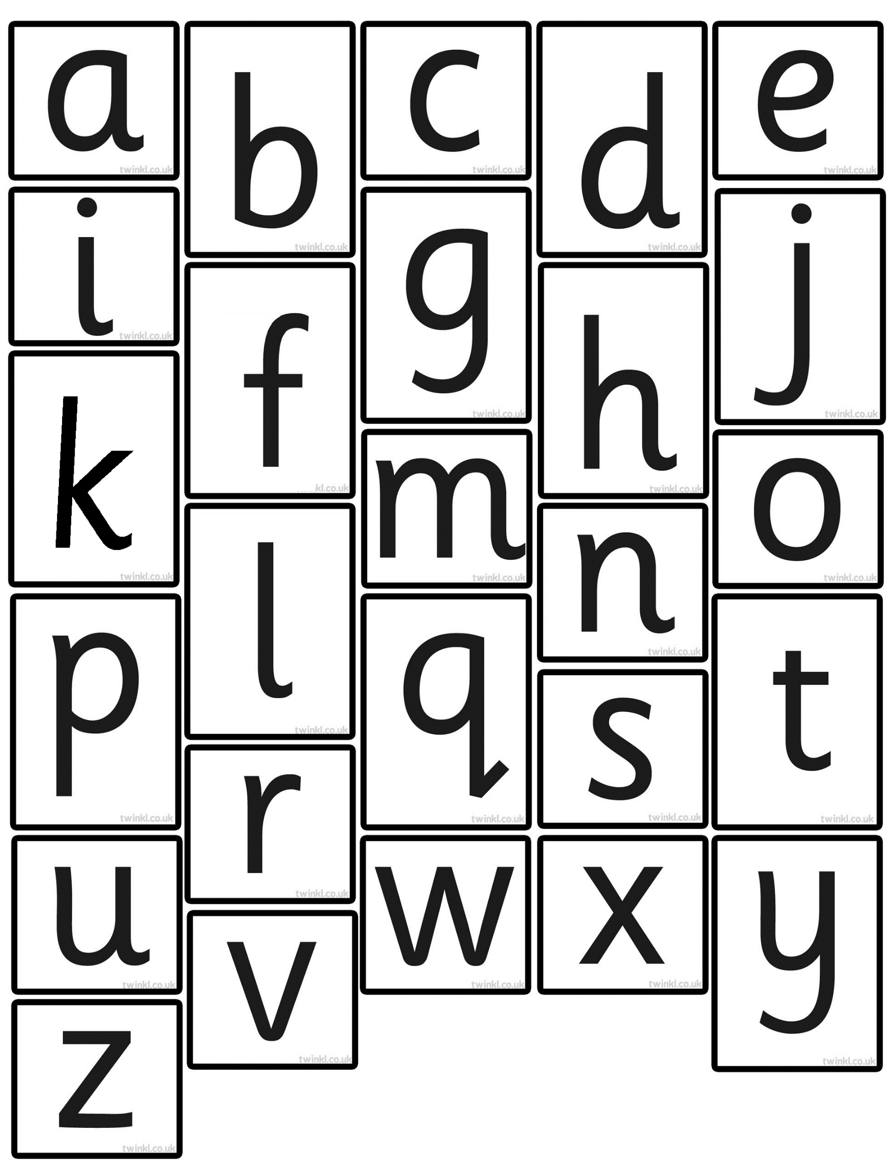
PRINT X 2 COPIES
LAMINATE SEPARATELY
CUT EACH LETTER INDIVIDUALLY.
LABEL EACH LETTER WITH THE CHILD’S NAME AND SURNAME

